**1.COLUMN CHART:**

**R&D Spend by State**

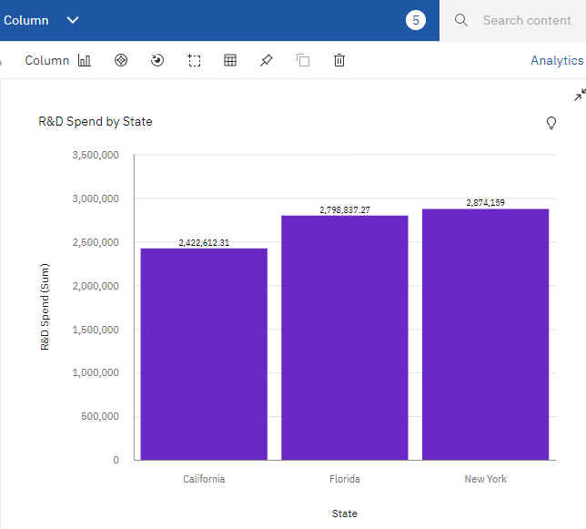

**2.BUBBLE GRAPH**:

**R&D Spend by State with points for Marketing Spend**

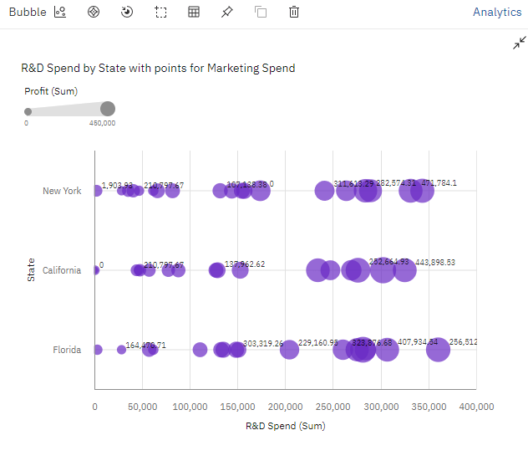

**3. PIE CHART:**

**R&D Spend by State**

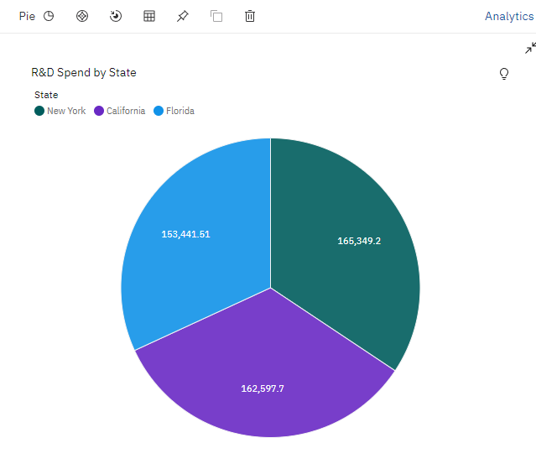

**4.AREA GRAPH:**

**Profit by Administration**

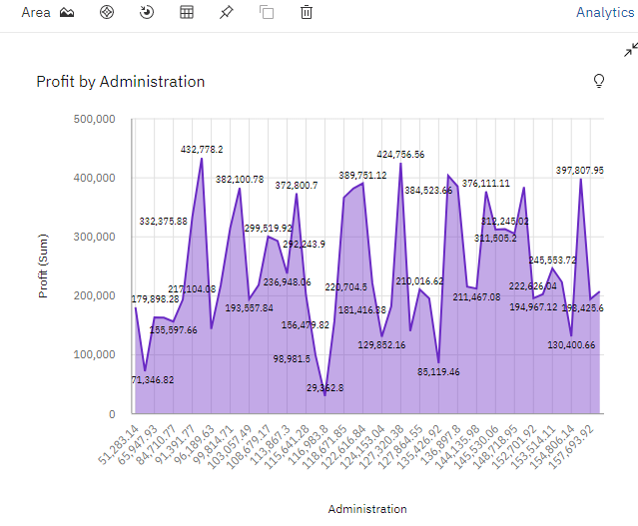

**5.BAR GRAPH:**

**State by R&D Spend**

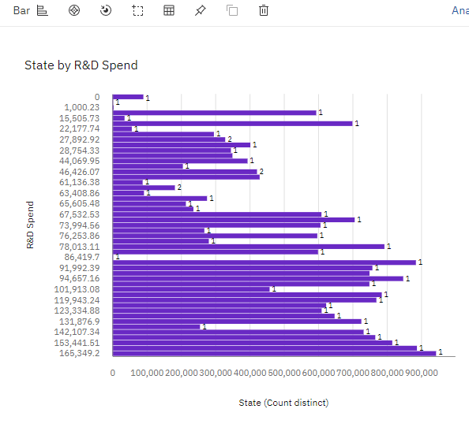

**6.STACKED BAR :**

**State by R&D Spend colored by Marketing Spend**

